DK- Big Ideas Simply Explained " 7册，精美英文原版pdf

DK- Big Ideas Simply Explained "
人类的思想"百科丛书英文原版，PDF原装精排版7本
DK's general reference books bring topics to life with illustrations, design, and fully comprehensive content across a variety of subjects from oceans to planets, medicine and religion. Including a vast range of atlases and manuals, DK’s general reference books contain everything you could want to see, learn and know about a wide range of captivating subject matter. Keep facts at your fingertips for daily perusal, research or to feed your thirst for knowledge by filling your shelves with DK’s general reference books today.
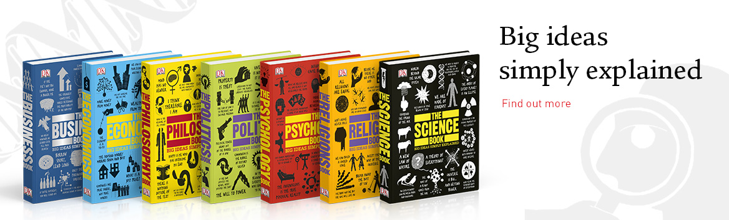
http://www.dk.com/us/general-ref ... ly%20Explained~ref1
1. The Business Book
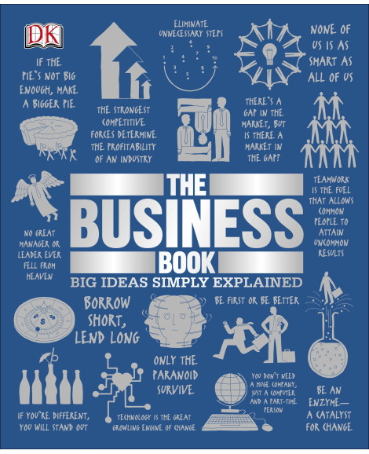
2. The Religions Book
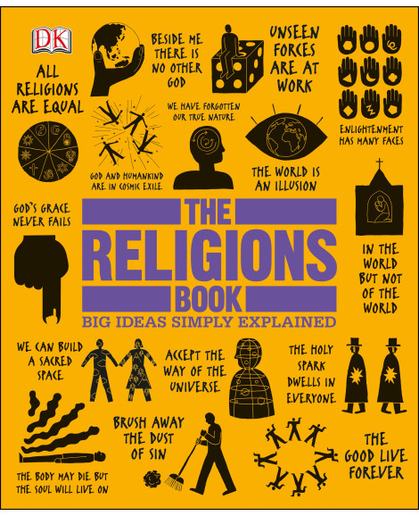
3. The Philosophy Book
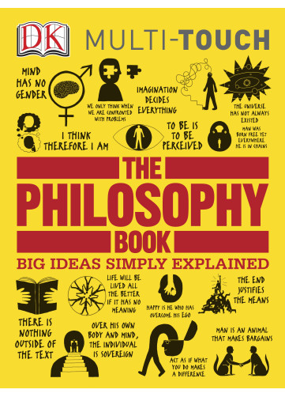
4. The Psychology Book
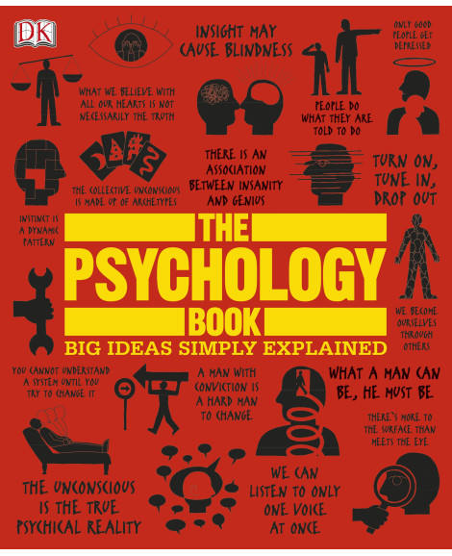
5. The Science Book
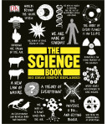
6. The Politics Book
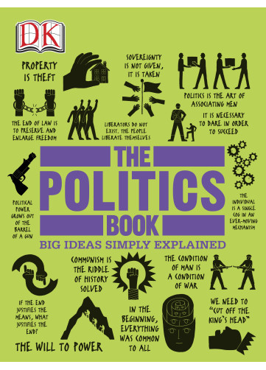
7. The Economics Book
