DK. Do Not Open An Encyclopedia of the World 不要打开世界百科全书

DK. Do Not Open An Encyclopedia of the World 英文原版 （258页）

好书才拿来免费分享，少量图的细节有点怕怕，想看要做好心里准备哟！
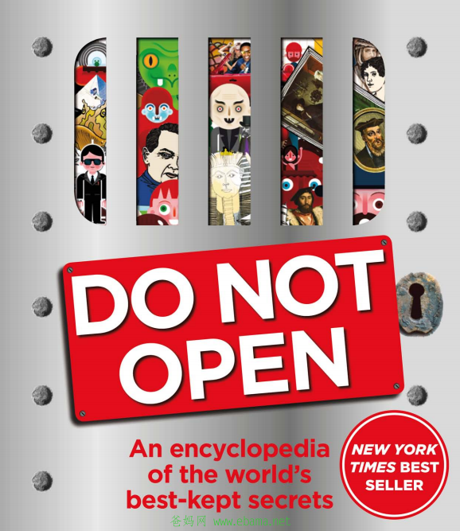

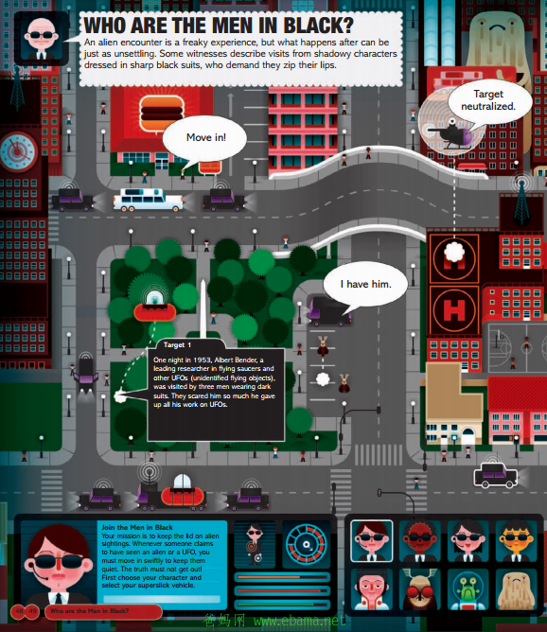

Introduction:From weird mysteries, freaky facts, and cool coincidences, Do Not Open explores what lies between the known and the unknown. Discover lost worlds, unravel secret codes, marvel at mysterious places and meet spooks, spies, secret keepers, and scandal-makers.
Psst! Want to know a secret? Do you dare open me up? Because inside you\’ll find the incredible TRUTH about mind-boggling confidential stuff \’they\’ don\’t want you to know! And wanna know something else? Find out where the Bermuda Triangle is, whether alien abductions actually happen, and the truth about crop circles. Explore lost worlds, unravel secret codes, marvel at mysterious places and meet spooks, spies, secret keepers and scandal makers of the world. When you\’ve finished riddle solving, close me up in my funky cage so no one else can get at my secrets! But ssh! Don’t tell a soul.
更

