DK《Help Your Kids With》系列之语言艺术、数学、科学和电脑编程，大人和孩子可以一起学习。百度网盘分享，高清PDF格式。
1、Help Your Kids With Language Arts: A visual problem solver for kids and parents
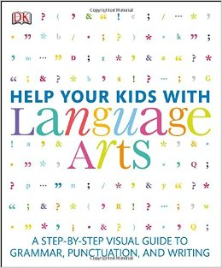
减少学习压力和帮助孩子完成家庭作业！
Reduce the stress of studying English and help your child with their homework!
The perfect guide for parents who want to assist their children with schoolwork, Help Your Kids with Language Arts is designed to make all facets of studying the English language easy and interesting.
Presenting the ins and outs of English in a clear, visual, and accessible style, Help Your Kids with Language Arts covers everything from the basic concepts of grammar, punctuation, spelling, and communication skills to some of the more challenging ideas that face students today.
2、Help Your Kids with Math: A visual problem solver for kids and parents
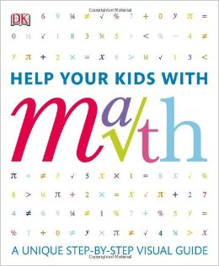
Studying math is often a source of great anxiety for children and also proves troublesome for parents helping with their homework. Using uniquely accessible illustrated stress-free approach, Help Your Kids with Math looks at every aspect of math, from simple sums to simultaneous equations, and explains each facet in easily understandable language so that adults and kids can master the subject together. Tricky concepts are explored and examined step-by-step, so that even the most math-phobic individual will be able to approach and solve complex problems with confidence.
3、Help Your Kids with Science
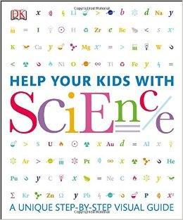
Following the success of Help Your Kids with Math, Help Your Kids with Science is a comprehensive and stress-free approach to science.
With clear graphics, instantly understandable diagrams, and welcoming, jargon-free text — covering all the important areas of biology, chemistry and physics — Help Your Kids with Science is a great resource for children and adults to learn even the most complex science problems with confidence.
Whether it's working with the Periodic Table, the threes laws of motion, or trying to explain polarity and magnetic fields, Help Your Kids with Science is a great resource for parents.
Help Your Kids with Science also includes a glossary of key science terms and symbols.
4、Help Your Kids with Computer Coding
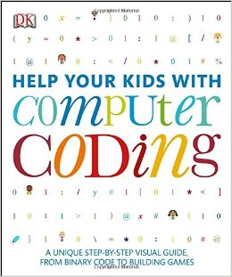
Take your kids from browsing to building the web with the latest in DK's award-winning Help Your Kids series: Help Your Kids With Computer Coding. Computer programming is one of the fastest-growing industries and highest paid college degrees, and learning to code promotes a way of thinking helpful for every budding brain. Yet 9 out of 10 schools don't even offer computer science classes to students, according to code.org. Help correct this disparity by introducing your kids to the world of computer programming early, with a fun and approachable method. This book begins by introducing the essential concepts of programming with simple instructions, and without specialized computer lingo. Fun projects throughout let kids start putting their computer skills into practice and build their own code using Scratch programming and Python, the two most popular languages. Also included are profiles on coding stars and insights in technology such as the Raspberry Pi mini computer. In typical DK fashion, colorful graphics and step-by-step instructions assist readers in starting to think like their computers.

